**Part 4 Comments**

* “We generated a total of 50,000 stock price paths to…”
* Better to state the exact time period, which is 1 month



* I would believe that there will be 2 sets of stock price paths, one where N=21 and another when N=84?
* If so, better to display the 2 separate charts side by side as with how the hedging error is distributed
* The existing chart in the report seems rather low-resolution too, better if the resolution can be increased significantly

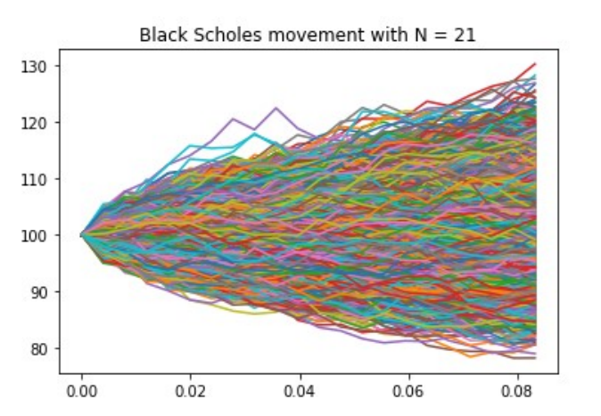

* “at every time step, for N=21 and N=84”
* “and the charts **above** show…”



* “but the standard deviation of hedging errors when N=21 is almost twice of that of when N=84”



* Standardise formatting of “PNL”, sometimes it is referred to as “pnl” and others, “P&L” etc
* “at a much lower frequency”



* “in the underlying prices between rebalancing trades”



* “In addition, as can be seen from the charts above, the hedging errors exhibit negative skews (i.e **long** tail towards the left”



* “whereby an investor can **experience extreme left tail events (huge losses)** which would be..”



* Try to differentiate the headers of the discussions more, “Discussion” and “Qualitative Assessment” are very similar terms
* Capitalise header text (e.g. Discussion of the Results, Qualitative Assessment of the Results)
* “a true indicator of the underlying volatility”



* “at about four times per day as compared to about daily”



* “increases to the hedging frequency (N) ..”

